Unearthing the environmental impact of human activity – A global CO2 emission analysis

1. **INTRODUCTION**
   1. Overview

Global warming is one of the biggest challenges currently being faced by the human race.

* 1. Purpose

Excessive emission of CO2 can cause harm to many living creatures

1. **PROBLEM DEFINITION AND DESIGN THINKING**
   1. Empathy map

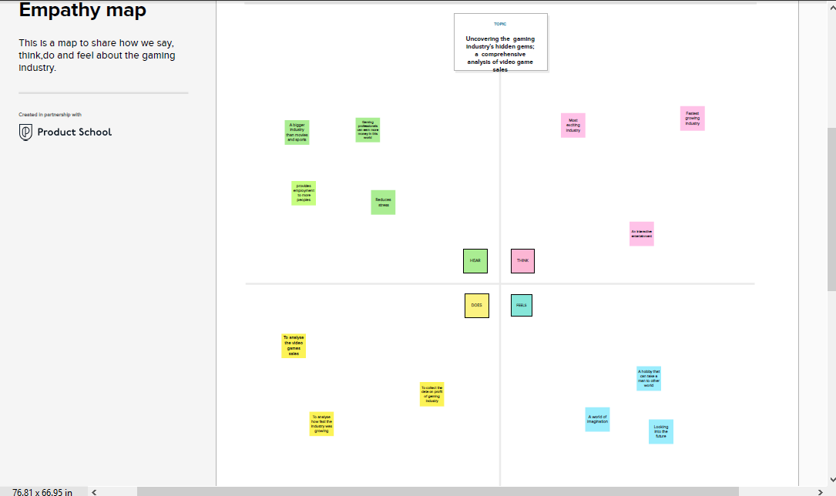

* 1. Brain storming map

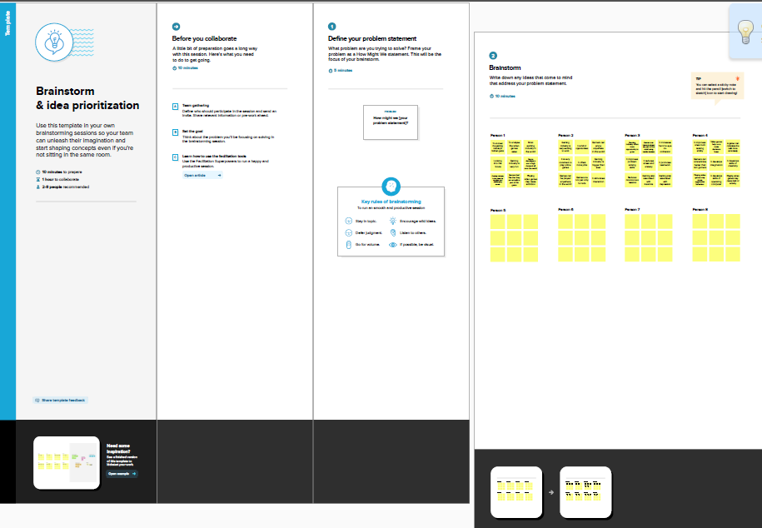

**3.RESULT**

This data may include the information about co2 emission on various country for different reasons

All over the world **RUSSIA** has the more CO2 emision.

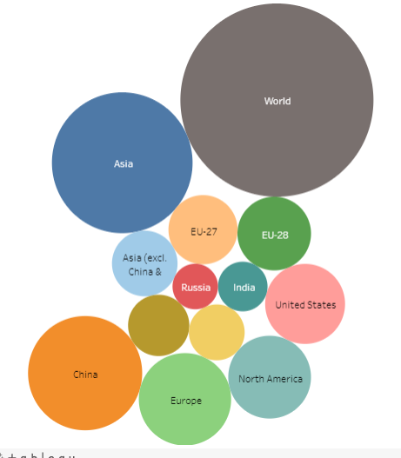

1. **ADVANTAGES AND DISADVANTAGES**

Carbon dioxide is an important greenhouse gas that helps to trap heat in our atmosphere. Without it, our planet would be inhospitably cold. However, an increase in CO2 concentrations in our atmosphere is causing average global temperatures to rise, disrupting other aspects of Earth's climate

1. **APPLICATIONS**

Carbon dioxide is used as a refrigerant, in fire extinguishers, for inflating life rafts and life jackets, blasting coal, foaming rubber and plastics, promoting the growth of plants in greenhouses, immobilizing animals before slaughter, and in carbonated beverages

1. **CONCLUSION**

Here by conclude that without CO2 no one can live . Massive emission of CO2 can harm many living creatures.

1. **FUTURE SCOPE**

emissions are **indirect GHG emissions associated with the purchase of electricity, steam, heat, or cooling**